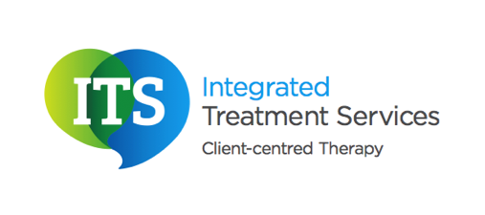

Stammering – Palin Parent Child Interaction (PCI)
- What is Palin PCI?
Palin PCI is a programme that was developed by the Michael Palin Centre for children with a stammer.

After an initial assessment, one our Speech and Language Therapists may recommend Palin PCI. When a child has a stammer, with the support of a Speech and Language Therapist, parents can have a huge impact in helping their children to achieve fluent speech.

Palin PCI is an indirect approach as therapy focuses on adapting the environment and the parent’s interaction style to help the child to achieve fluent speech. The programme involves no direct work on the child’s speech unless the Speech and Language Therapist recommends this programme in conjunction with another such as the Lidcombe Programme.

The Speech and Language Therapist will recommend the best way in which the Palin PCI should be implemented. This will dependent upon each unique case, but usually the Therapist will recommend that the parents attend weekly therapy sessions. The parents will be asked to bring a video of themselves interacting with the child. The Speech and Language Therapist will provide the parents with information on what they should record. The Therapist will usually watch the video with the parents, pausing at appropriate times to provide the parents with feedback.

Feedback will be structured around the environment and the parent’s communication style. The Therapist will discuss the positive things the parents are doing to help their child to achieve fluent speech. The Therapist will also give the parents advice on additional strategies they could use as well as discussing how the environment could be modified.

Some of the weekly sessions will be practical sessions. The Speech and Language Therapist will work alongside the parents in a practical activity with the child, helping them to implement the strategies recommended.

Palin PCI has been shown to increase children’s fluency which enables them to communicate effectively. It also gives parents a broader insight into stammering and equips them with strategies they can use.

If you would like further information on Palin PCI, please contact us on 0845 838 2921 or info@integratedtreatments.co.uk

