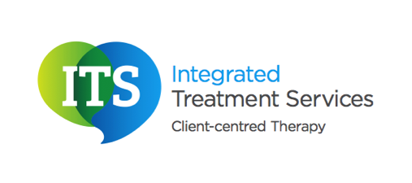

Communication Cards

These cards are intended to help individuals who have difficulties with their speech, language and communication. They aim to help individuals to maintain their independence and ability to make choices.

The cards should be cut out and the text in bold should be personalised.

Card A
Purpose: To use on a trip to the library to ask someone where a particular genre of books are kept, e.g. history, science fiction.
 Hello, Please can you show me where the history books are?

Card B
Purpose: To use on a visit to the café to ask for a drink.

Hello, please can I have a large coffee with no milk and one sugar?

Card C
Purpose: To use on a visit to the bank to draw out money/to draw out a pension

Hello, please can I draw out £100, if possible I would like it in £10 notes

Card D
Purpose: To use when picking up prescriptions from the chemist
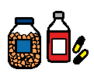Hello, I would like to pick up my prescriptions

Card E
Purpose: To use when going to the bakery and asking for some items
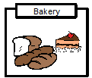 Hello, please can I have a loaf of white sliced bread?

Card F
Purpose: To use when getting into a taxi to tell them where they need to go, you could also personalise this to include details of the return journey.
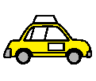 Hello, please can you take me to the supermarket?

