

Colourful Semantics – Level 5

Thank you for downloading our Colourful Semantics Pack Level 5.
We have created this pack to help parents and teachers to use level 5 of Colourful Semantics with their children/students.
Level 5 is the describing aspect of a sentence and this level should be introduced once the child/student can use levels 1 to 4.
For information on the first 4 levels, please read our Colourful Semantics starter pack. You may also wish to watch our Introduction to Colourful Semantics video and read the Colourful Semantics module one PowerPoint.

Recap of the Levels of Colourful Semantics
Level 1



Level 2

Level 3

Level 4

Level 5 – Describe?


‘Describe’ is the adjective in the sentence. An adjective is a describing word. It is always represented by the colour purple. It is fifth to appear on the strip. ‘Describe’ can be moved to different places on the strip to add description to other words in the sentence.

Examples
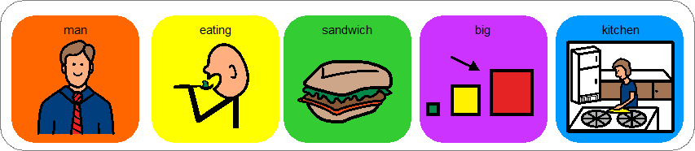
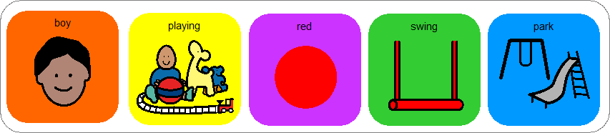
The man is eating a sandwich in the big kitchen

The boy is playing on the red swing in the park
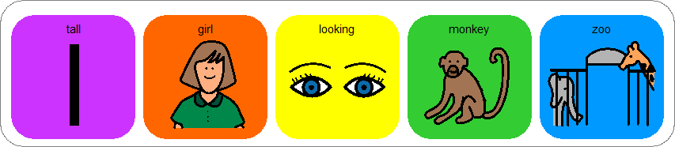

The tall girl is looking at a monkey in the zoo

If you require assistance in using this pack or are interested in booking a training course with us, please contact us on 0845 838 2921 or info@integratedtreatments.co.uk

